**Cell Division**

**Mitosis and Meiosis**

**Cell Division Overview**

* **Two main types**:
  1. **Mitosis** → For growth & repair. Produces **2 identical diploid (2n)** daughter cells.
  2. **Meiosis** → For sexual reproduction. Produces **haploid (n)** gametes (sperm/ova) with **half** the chromosome number.

**Chromosome Structure**

* **Chromosome**: Coiled, condensed DNA strand.
* **Replicated chromosome**: Two **sister chromatids** (identical copies) joined at the **centromere**.
* **Centromere**: Region holding chromatids together; attaches to spindle fibers during division.
* **Spindle fibers**: Connect centromere to **centrosome** to help pull chromatids apart.

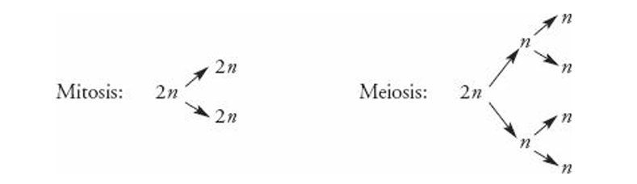

**DR SALMA KHALED BIOLOGY EDUCATOR**

**Cell Cycle Stages**

1. **G0 (Resting phase)** → Cell exits the cycle, performs normal functions, no division.
2. **G1 (Gap 1)** → Organelle replication.
3. **S (Synthesis)** → DNA replication (chromosomes duplicate).
4. **G2 (Gap 2)** → Check any error.
5. **Mitosis (M phase)** → Division of nucleus (**Prophase → Metaphase → Anaphase → Telophase**).
6. **Cytokinesis** → Division of cytoplasm into two cells.

**Interphase** = **G1 + S + G2** (about **90%** of cell’s life).

* Nucleoli visible.
* Nuclear membrane intact.
* DNA is in **chromatin** form.

**Mitosis Order** → **P M A T**  
(Prophase → Metaphase → Anaphase → Telophase)

**DR SALMA KHALED BIOLOGY EDUCATOR**

**Mitosis**

Mitosis is the division of the **nucleus**. It has **4 phases**:

**1. Prophase**

* Chromosomes condense and become visible.
* Nucleoli disappear.
* Spindle fibers form in the cytoplasm (from centrosome to centrosome).
* Centrioles move toward opposite poles.
* Nuclear membrane starts breaking down.

**2. Metaphase**

* Chromosomes line up single file at the **equator/metaphase plate**.
* Centrosomes are at opposite poles.
* Spindle fibers connect centrosomes to chromosome centromeres.

**3. Anaphase**

* Centromeres split, separating sister chromatids.
* Spindle fibers pull chromatids toward opposite poles.
* Shortest phase of mitosis.

**4. Telophase**

* Chromosomes gather at opposite poles.
* Nuclear membrane reforms.
* Chromosomes uncoil into threadlike form.
* Nucleoli reappear.

**DR SALMA KHALED BIOLOGY EDUCATOR**

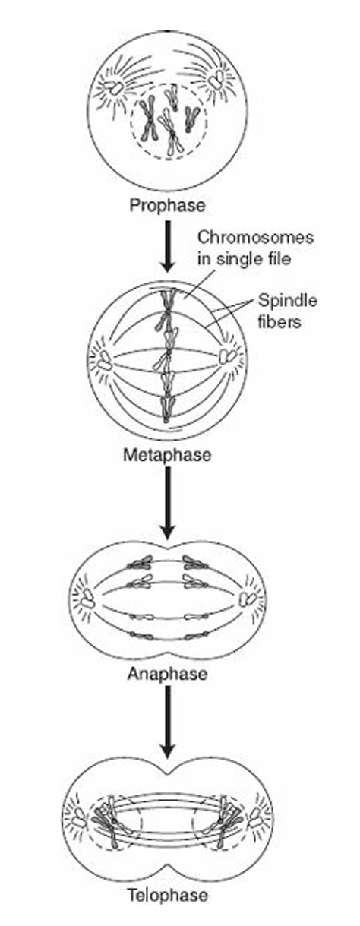

**Cytokinesis – Division of the Cytoplasm**

**In Animal Cells**

* A **cleavage furrow** forms in the middle.
* Cytoplasm pinches inward.
* Two daughter cells completely separate.

**In Plant Cells**

* A **cell plate** forms in the middle.
* Daughter cells remain attached.
* **Middle lamella** (sticky layer) cements adjacent cells together.

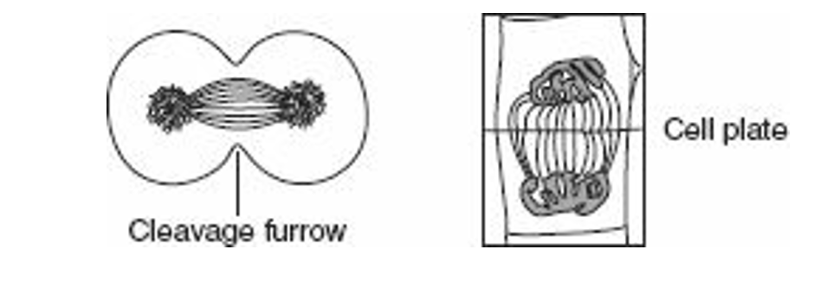

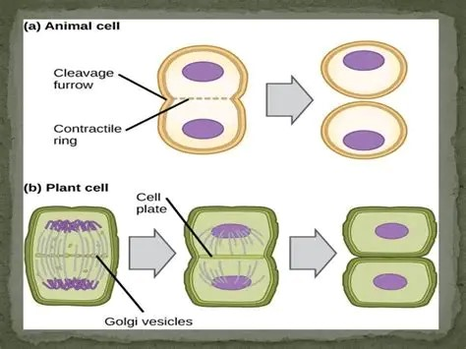

**DR SALMA KHALED BIOLOGY EDUCATOR**

|  |  |  |
| --- | --- | --- |
| **Feature** | **Meiosis I** | **Meiosis II** |
| Nickname | Reduction division | Equational division |
| Chromosome number after division | Reduced from **diploid (2n)** → **haploid (n)** | Stays **haploid (n)** |
| Homologous chromosomes | Separate | Already separated in Meiosis I |
| Sister chromatids | Stay together | Separate |
| Crossing-over | Occurs in Prophase I | Does not occur |
| Metaphase arrangement | **Double file** (pairs of homologous chromosomes) | **Single file** (individual chromosomes) |
| Genetic variation | Produced by crossing-over + independent assortment | No new variation (just separation) |
| End product | 2 haploid cells (still with sister chromatids) | 4 haploid gametes (single chromatids) |

**DR SALMA KHALED BIOLOGY EDUCATOR**

